Please include your student number in filename (e.g. 1234567)

|  |  |
| --- | --- |
| Student number: | 2147105 |
| Course title: | CS1S |
| Questions answered: | ALL |

Q1.a) 1010 0110

2 + 4 + 32 + 128 = 166

b) 1010 0110

neg so negate = 0101 1001 +1 = 0101 1010 = 2 + 8 + 16 + 64 = 90 = -90

c)

;R1 := a

;R2 := b

;R3 := c

;R4 := d

load R3,c[R0]

load R4,d[R0]

sub R3,R3,R4 ; R3 := (c-d)

mul R1,R2,R3 ; R1 := b*R3

store R1,a[R0]

d) mod = 0. R1= 0, R2 = $0300. R2 = $0300 + 0. instr[0] = 0300. r4 = 4. R5 = 2. r3=0. out = 0.

mod = 0045. R1= 0045. R2 =

the code is changing itself – self modifying code. The code is loading and storing a label that is part of the code being executed, instead of a variable in data, like mod. This is not recommended as it is hard to read and debug. You cant read what will happen until you have executed it, as the code changes will it is running.

c)

2.a) The behaviour of the mux1 can be defined as z=(if c=0 then x else y). The circuit takes 3 inputs, x, c and y. And 1 output, z. mux1 enables the creation of complex programs because it allows an output to be selected depending on a control signal. This is required in reg1 circuits for maintaining or updating their value. It is also used in register files, which are many reg1 circuits, for selecting which register value to output. A CPU is made up of many of these basic circuits that use mux1’s. Truth table is:

|  |  |  |  |
| --- | --- | --- | --- |
| c | x | y | z |
| 0 | 0 | 0 | 0 |
| 0 | 0 | 1 | 0 |
| 0 | 1 | 0 | 1 |
| 0 | 1 | 1 | 1 |
| 1 | 0 | 0 | 0 |
| 1 | 0 | 1 | 1 |
| 1 | 1 | 0 | 0 |
| 1 | 1 | 1 | 1 |

b) (x and y) xor (x and z)

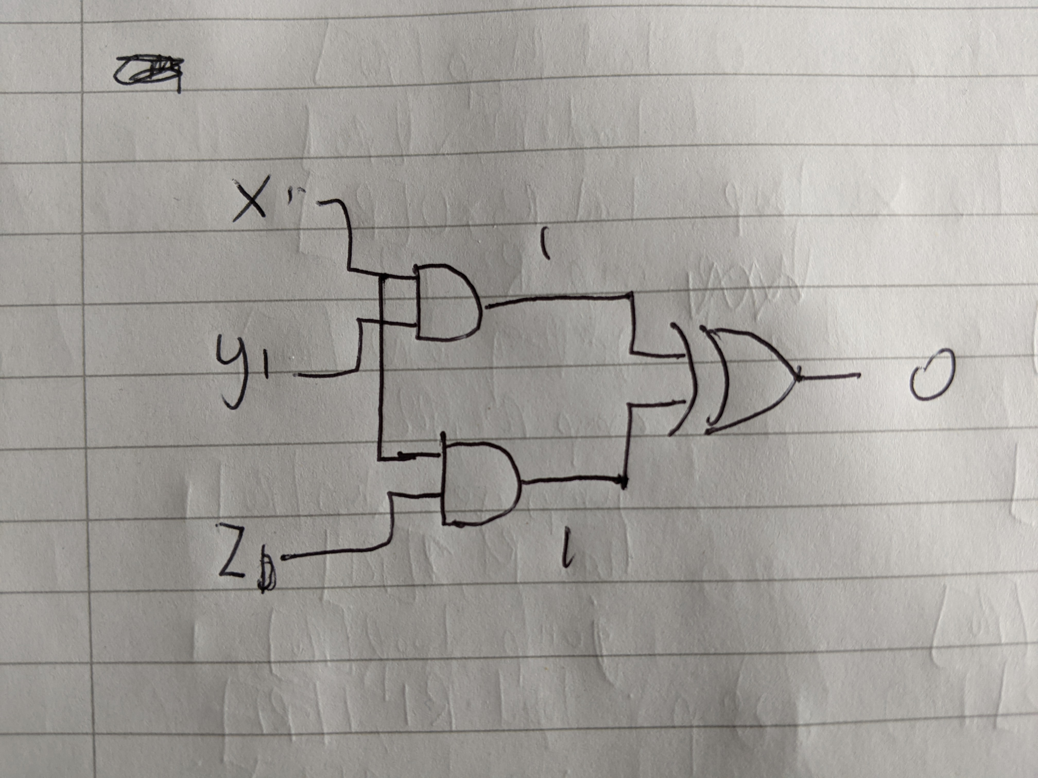

c) It would take 1ms x 20 logic gates to pass through = 20ms for all the values in the circuit to be valid, which means obeying the laws of Boolean algebra. 1s / 20ms = 50. Clock speed needs to be 50Hz. If the clock speed was faster than this, then the dff’s in the circuit could update their state before the logic gates produced correct values, causing hazards (glitches).

d)i) a linked list makes it much easier to add and remove transactions at different places in the lists. An array has to run in sequence. However, the linked list takes up more data space than an array because it has the ‘next’ node to link it to the next item.

ii)

p = p

store = store

total = 0

while p /= nil:

if account_id == store:

then total = total + value

p = (*p).next

iii)

p = p

store = store

total = 0

loop if (p == nil)=True then goto done

if (account_id /= store)=True then goto skip

total = total + value

skip p = (*p).next

goto loop

done store total

iv)

add R1,R0,R0 ;total = 0

load R2,p[R0]

load R3,store[R0]

loop cmp R2,R0

jump eq done[R0]

load R4,1[R2]

cmp R3,R4

done store R1,total[R0]

trap R0,R0,R0